
Waste Management Operative - Loader

Salary: £25,185 up to £26,403 per annum pro rata
Grade: 3
Location: Hinckley, Leicestershire
Contract: Permanent contract, 37 hours per week, full time

About the role
We currently have a vacancy for a Waste Management Operative - Loader position within our Waste Management Team.

Your role will include working as part of a small team collecting waste across various waste streams, such as refuse, food waste, dry recycling or garden waste across borough.

What you will be doing
- Work as as part of a team to complete daily rounds.
- Collecting different types of waste across the borough.
- Use equipment safely and follow health and safety procedures.
- Help with other duties such as cleansing, yard work or seasonal tasks.

About you
Applicants should be committed individuals who are looking to make a difference to the high-profile and priority services of the council.

You will be expected to behave in accordance with the Council’s values which include being customer focused and courteous when interacting with members of the public, whilst ensuring service standards are met.

Essential criteria
- You must be physically fit, able to walk long distances each day, move wheeled bins, containers or sacks and any other waste receptables, as required.
- High levels of customer service are essential as part of this key frontline service role.

Find out more
For an informal discussion about this exciting opportunity please call Barry Upton, Waste Management Team Leader on 01455 255778.
Apply with your CV and supporting statement via our online application form at https://jobsandcareers.hinckley-bosworth.gov.uk/ or for an application pack call 01455 255836 quoting position reference: C822
Closing date: 14 July 2026
Interview date: week commencing 27 July 2026
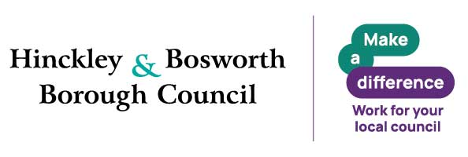
Why Join Hinckley & Bosworth Borough Council
A great place to work, grow and make a real difference. Join a flexible, supportive council offering great development, strong wellbeing, financial benefits and values that put people first.
Make a real difference in Hinckley & Bosworth.
Benefits
- Flexible working – flexi‑time, hybrid, part‑time and compressed hours (role‑dependent)
- Generous annual leave – 26–33 days + bank holidays
- Career development – training, funded qualifications, apprenticeships, e‑learning
- Strong wellbeing support – EAP & counselling, occupational health, wellbeing sessions
- Financial benefits – competitive pay, cost‑of‑living increases, local government pension scheme
- Salary‑sacrifice schemes – tusker cars, tech, cycle to work
- Relocation package up to £5,000
- Lifestyle discounts – retail, travel, entertainment and more
Values and behaviours

We are energetic and passionate, proud of and dedicated to our area.

We strive for excellence. We learn, innovate, challenge, seek out opportunities and embrace new ideas.

We trust, respect and are honest. We listen to each other, to our communities and to our partners and work with them supportively to get things done.

We put the needs of our customers first. We care about being the best we can be and take responsibility for our actions.
Inclusive Employer
We are a Disability Confident and Care Leaver Friendly Employer. Guaranteed interviews are offered to eligible applicants who meet the essential criteria. Reasonable adjustments are available throughout the recruitment process.
Eligibility criteria applies

